Getting help

Google it, read the R manuals, or post to a forum (e.g., on stack-overflow)

How to ask questions:

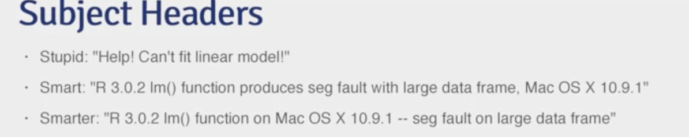

* Describe the goal
* Follow up with the solution if found